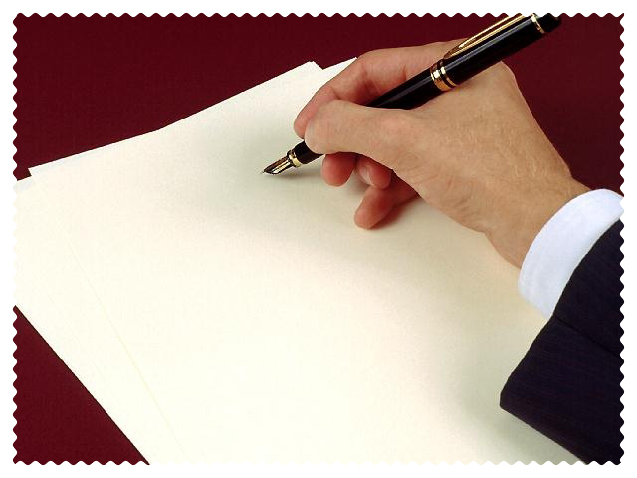

The Pen

The Pen

INTRODUCTION

Peculiar Pen Facts

  - “pen” from the Latin penna/pinna meaning feather (WEBSTER)

  - It’s a fact! The rise and spread of Christianity increased the demand for permanent written religious documents. (ENCARTA ENCYCLOPEDIA)

  - The quill pen was the principal writing implement for nearly 1300 years! (E.E.)

  - The Parade of the Pens!

    - Quill pen - 6th Century A.D.
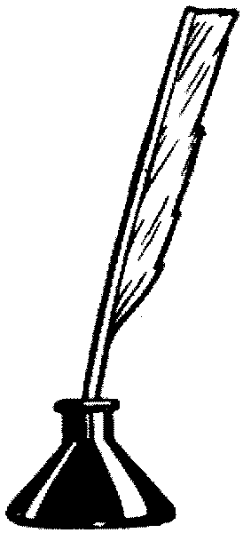
    - Fountain pen - 1884 Lewis Waterman patents first practical fountain pen with its own reservoir

    - Ball point pen - 1938, first practical ball point pen invented by two Hungarian brothers

    - Fiber tip pen - 1962, first practical fiber tip pen invented by Yukio Horie of Japan

  - There is no lead in a lead pencil! A pencil does not contain any lead, but is composed of graphite (a form of carbon) and clay.

Pen Vs. Pencil

More Permanent____________ Easily Erased_______________
Longer Lasting Use__________ Must be sharpened frequently__
__________________________ __________________________
__________________________ __________________________
__________________________ __________________________
__________________________ __________________________
More Permanent __ Easily Erased_______________
Longer Lasting Use __ Must be sharpened frequently__
__________________________ __________________________
__________________________ __________________________
__________________________ __________________________
__________________________ __________________________

Are You Prepared for the Pen?

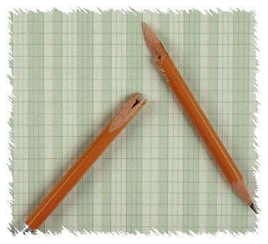
  - Do you enjoy writing?
_____________________________________________________________________________________________________________________________________________________________________________________________

  - Are you willing to do your best to make yourself prepared to work for the kingdom of God?
_____________________________________________________________________________________________________________________________________________________________________________________________

  - Write: a masterpiece of an essay.
_____________________________________________________________________________________________________________________________________________________________________________________________

The Preeminent Pen
  - Webster’s: preeminent: superiority; having paramount rank, dignity, or importance; outstanding

  - Places of Use
    - _________________________________________________
    - _________________________________________________
    - _________________________________________________
    - _________________________________________________
    - _________________________________________________
    - _________________________________________________

C. Scope of Influence
    - _________________________________________________
    - _________________________________________________
    - _________________________________________________
    - _________________________________________________
    - _________________________________________________

The Powerful Pen

  - Have you been influenced by something that you have read?

  - “The Pen of a Ready Writer” Psalm 45:1 God can speak through your writing.

  - Examples of Powerful & Influential pieces of literature.
    - _____________________________________
    - _____________________________________
    - _____________________________________
    - _____________________________________
    - _____________________________________
    - _____________________________________
    - _____________________________________
    - _____________________________________
    - _____________________________________
    - _____________________________________

  - ASSIGNMENT: Write a minimum of 150 words in answer to the question → DOES GOOD WRITING HAVE AN IMPORTANT ROLE IN CHRISTIAN MINISTRY?

The Perspicacious Pen

  - Websters: “perspicacious” plain to the understanding, especially because of clarity and precision of presentation

  - Precision Expression – vocabulary; succinctness

  - Clear Expression – effectively communicating

The Personable Pen
  - Webster’s: pleasant or amiable in person; (amiable – generally agreeable)

  - Colorful Expression – How can your writing be ‘colorful’?
    - ___adjectives_____________________________
    - ___detailed descriptions_____________________
    - ________________________________________

  - Beautiful Expression
    - Poetic
    - Pithy (having substance and point)
    - Memorable

The Polished Pen
There are three simple steps to developing a “polished pen”:
    - Write
    - Write
    - Write

CONCLUSION

  - By next class get a small notebook for your vocabulary words.
  - Highlight the following words in this outline and place them in your notebook with their definition and an example of it being used.

